ITEC3250

Assignment 1

100 pts

Due 9/3

Dr. Jonathan Jenkins

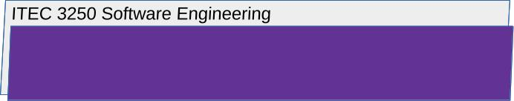

Requirements

1 Files to Submit
lastnameFirstinitialA1.docx

All submitted files must be named with your first and last name as shown

2 Notes
- Number your responses as in the writeup, whether response is included or not
- To assist me in efficient scoring, use this document as a template, typing in your responses to each question.
- Your attention to detail in concisely and fully answering and exploring the question will be reflected in your score

3 Answer the Following Questions

Part 1: Process Models

1. Briefly explain and argue whether or not you argue the incremental process model is effective for the development of a smartphone/mobile device application

Recall that the process model determines how we arrange the process activities (design, implementation…) and whether we revisit the earlier ones.
Consider whether the project is affected by outside regulation or a need for predictability and requirements won’t change much , whether the project requirements would be expected to change often and whether the stakeholders need frequent feedback , and whether existing software could be reused to develop the software system

Part 2: Agile Development

- Choose a team task you have participated in, and briefly explain two ways that agile methods could be applied to your task.

For example, using the agile development techniques like frequent releases, what would this mean for your chosen task and how would it be carried out?

3 Submission

- Submit using the submission folder in D2L for this assignment
- For every assignment, create a new file to produce the submission
- Requirement: download or retrieve your submission after you submit it in order to check that your files are as you intend to be scored
- Resubmission is possible while the folder is open
- Latest scoreable submission is scored

